CS5785 – Homework 0

Team member: Siyi Fan & Wen Li

# 1. Task Statement

We wrote a python program using Enthought library to read the data from iris.data and plot a graph comparing each attribute value of a sample against each other. Figure 1.1 shows the graph we plot.

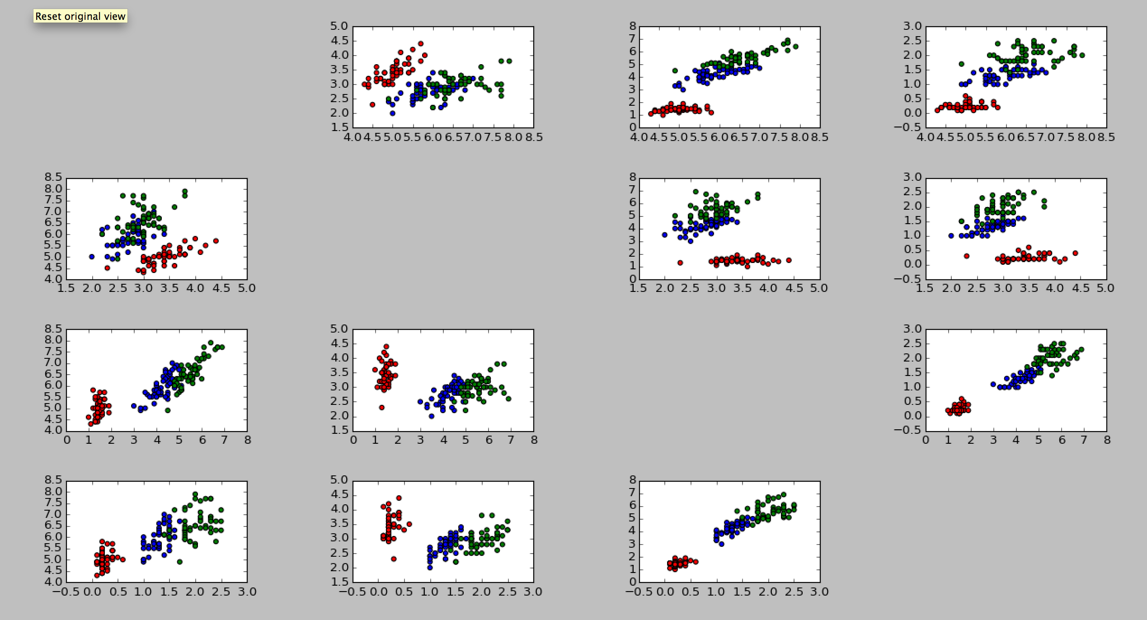

**Figure 1.1**

# 2. Interesting Finding